**Project Design Phase-II Data Flow Diagram &User Stories**

|  |  |
| --- | --- |
| Date | 16 October 2022  . |
| Team ID | PNT2022TMID17544 |
| Project Name | Plasma Donor Application |
| Maximum Marks | 4 Marks |

**Data Flow Diagram:**

A data-flow diagram is a way of representing a flow of data through a process or a system. The DFD also provides information about the outputs and inputs of each entity and the process itself. A data-flow diagram has no control flow — there are no decision rules and no loops.

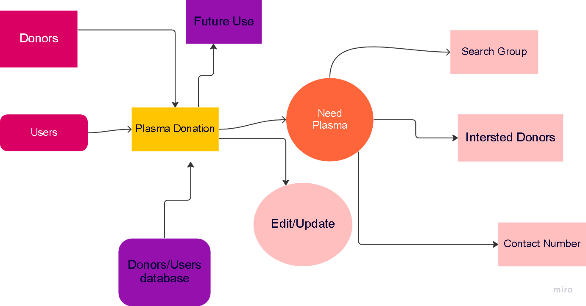

**Plasma**

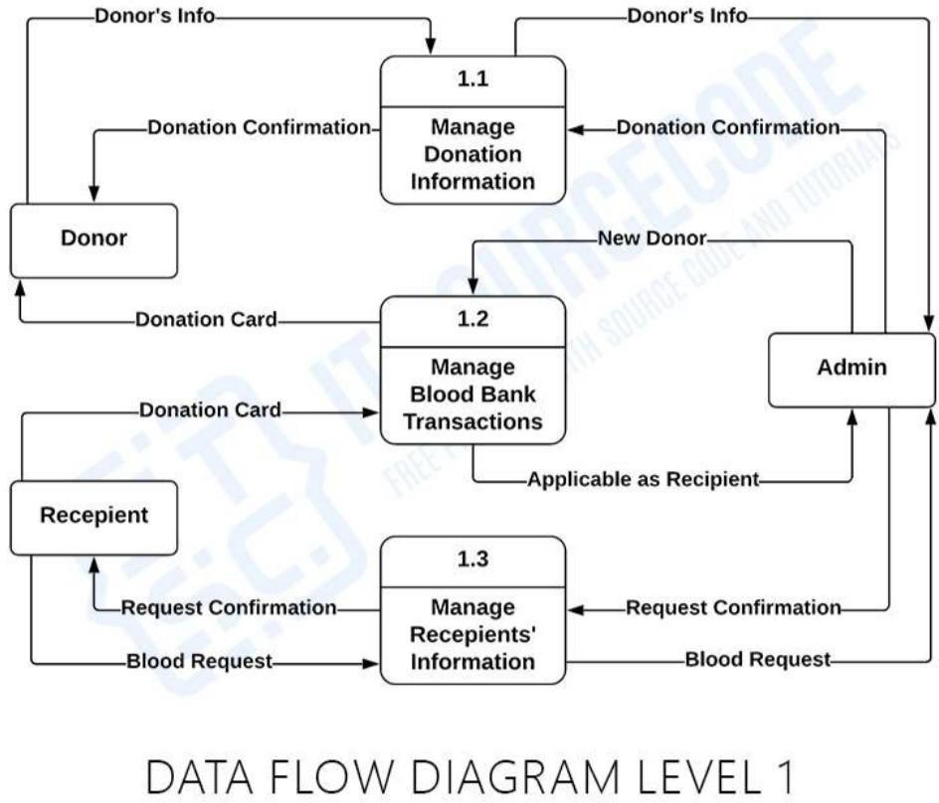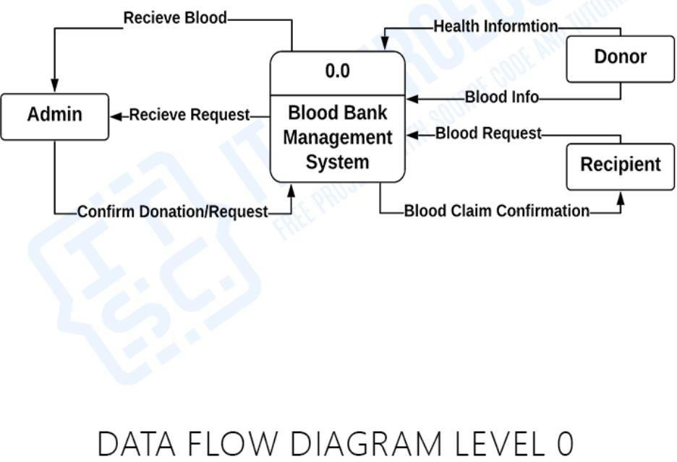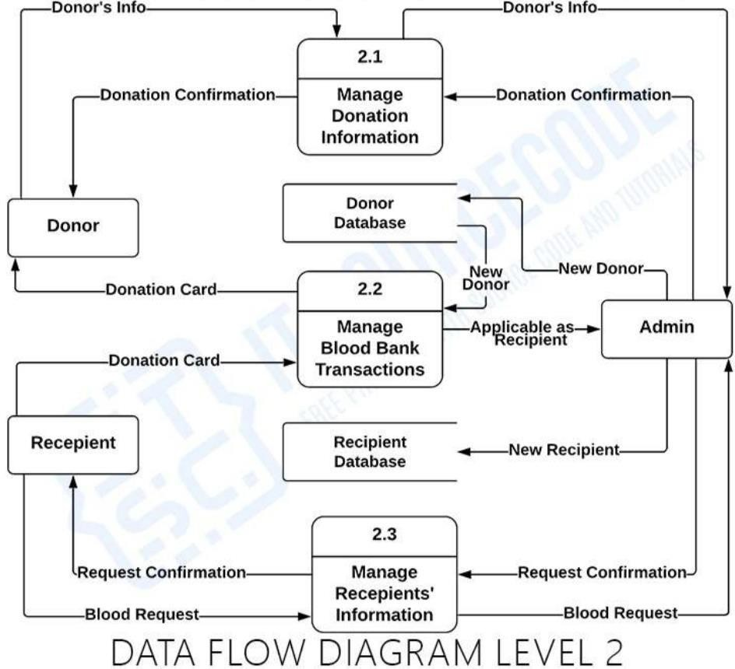

**Plasma**

User Stories

|  |  |  |  |  |  |  |
| --- | --- | --- | --- | --- | --- | --- |
| User Type | Functional Requirement  (Epic) | User Story  Number | User Story/Task | Acceptance criteria | Priority | Release |
| Donor | User Registration | USN-1 | As a user, I can register for the application by entering my email, password and confirming  my password. | I can access my account/dashboard | High | Sprint- 1 |
|  | Login | USN-2 | As a user, I can log into the application by entering email and  password. | I can receive confirmation email and click confirm | High | Sprint- 2 |
|  | Register for donor | USN-3 | As a user, I can log into the application and search result can be viewed in a list to donate plasma and confirm by  booking | I can register & access the dashboard with Facebook Login | Medium | Sprint- 3 |
| Patient/donor | Find the bank | USN-4 | As a patient, I can directly access the application and find the  plasma | I can access my account/dashboard | High | Sprint-- 1 |

|  |  |  |  |  |  |  |
| --- | --- | --- | --- | --- | --- | --- |
|  |  |  | available  bank |  |  |  |
|  | Request for plasma | USN-5 | As a user, I can enter into the application and find the current bank and request for plasma an state the  emergency. | I can register & access the dashboard with Facebook Login | Medium | Sprint- 3 |
| Administrator | Maintain the applications | USN-6 | As Administrator I can log into the application by entering email & password and maintaining details for  users | I can access my account/dashboard | High | Sprint- 3 |
| Plasma Bank | Send request | USN-7 | As a bank if plasma is required, the receiver will contact the  donor. | I can access my account/dashboard | Medium | Sprint- 3 |
|  | User credentials | USN-8 | Operator has registered then the software operator should be able to login to the web application. It  will be | I can access my account/dashboard | Medium | Sprint- 4 |

|  |  |  |  |  |  |  |
| --- | --- | --- | --- | --- | --- | --- |
|  |  |  | storied in database for  future use. |  |  |  |